Interactive Map Game 2: Excavation Design Document

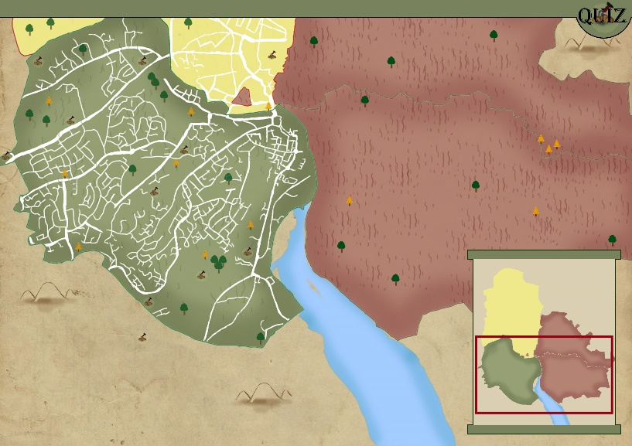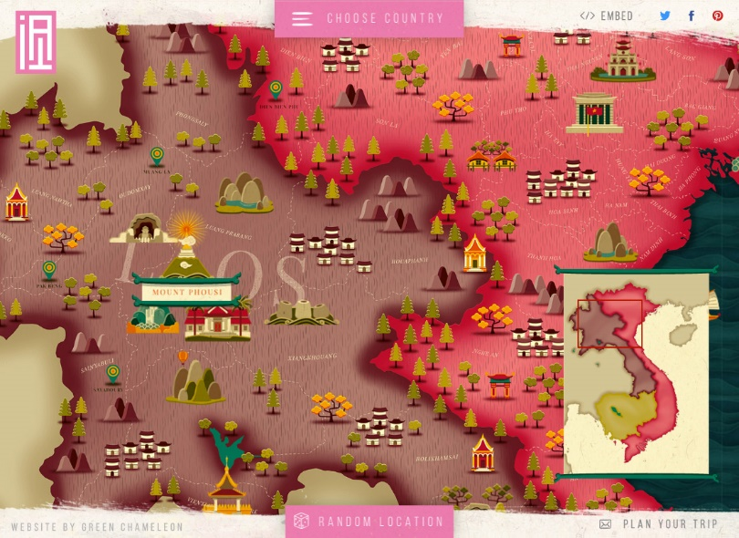Initial inspiration:

Figure 2: Initial mock up

Figure 1: Interactive map

The initial map presented a mock-up for our pitch presentation was heavily inspired by the interactive map featured in figure 1. The map featured consisted of a minimalistic approach, dotted lines to represent individual areas, as well as utilising flat colours in tangent to very light shading. Additionally, the initial minimalistic design in the mock-up was juxtaposed against the textured-warned down scroll like the backdrop of the game screen. The backdrop also featured hand-drawn components as opposed to the minimalistic style featured in elsewhere; this style choice represents the juxtapositioning between the heritage of the town and the emerging interactive technologies used to 'tell their story'.

Mood board:

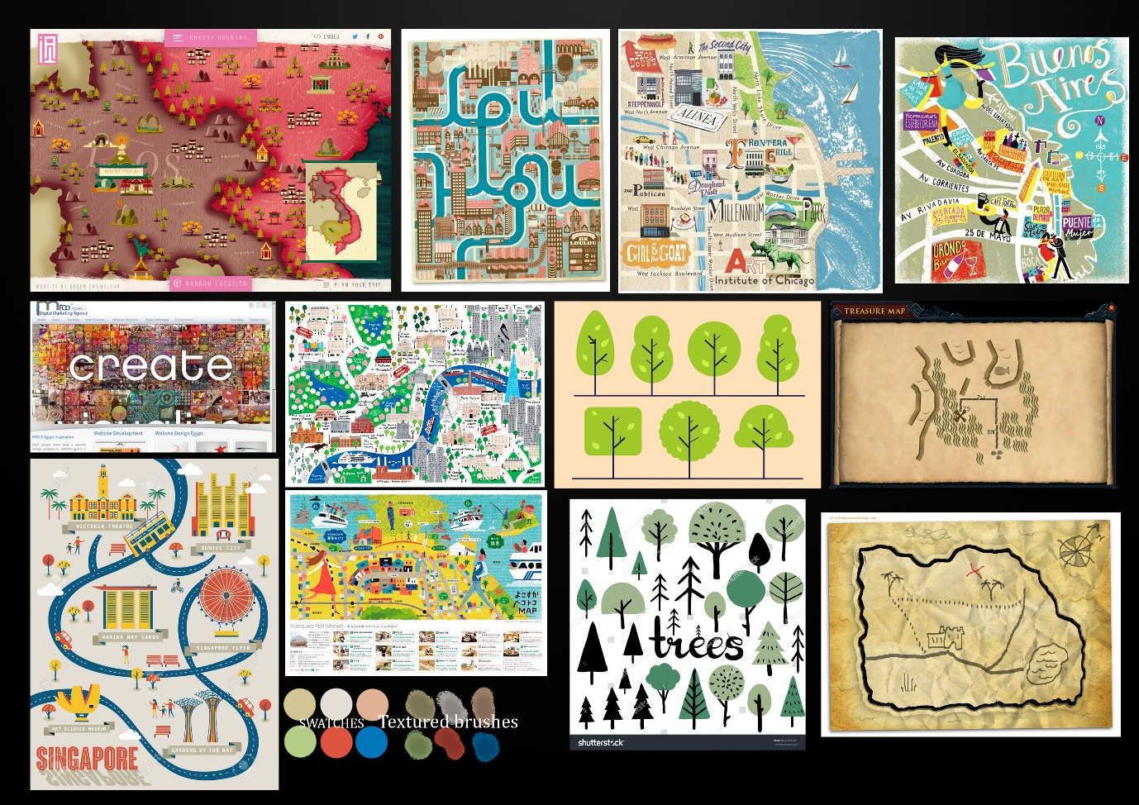

The mood board featured further explores the minimalistic style of its predecessor, as well as the scroll-like backdrop to further interpolate the juxtaposition theme briefly explored earlier.

Additionally, maps which feature textured brushes are evident in the mood board; this works well as opposed to the light shading featured in the initial mock-up, this is to create a more cohesive style that still incorporates the juxtaposition narrative the initial art style represents.

Much like the pallets featured in the initial mock up, the pallets featured in the mood board consists of varying shades of pastel and light colours, these are imperative in further aiding to the minimalistic style.

Creating the art:

